Collection Date 22nd Oct @ Bishop O’ Brien N.S.
What we collect
We accept:
- Men’s Clothing • Women’s Clothing
- Children’s Clothing • Household textiles i.e. Curtains, Towels
• Shoes • Handbags • Belts
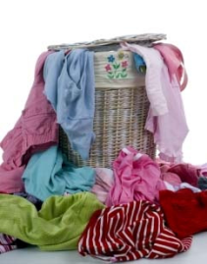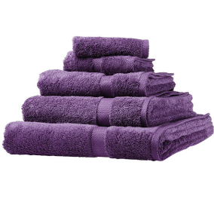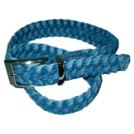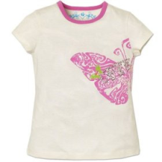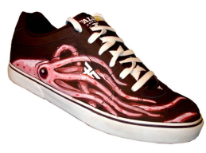
Unfortunately we cannot accept
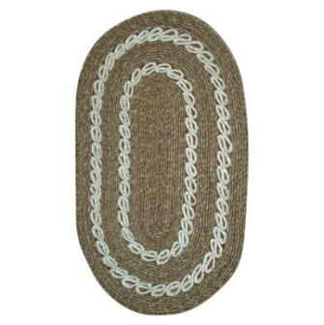
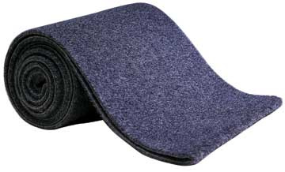
• Dirty or wet clothing
• Mats
• Carpets
- Duvets/Pillows
- Books
- Laptops or Mobile Phones

To organise a collection for your school/club or organisation please contact
Kris on 087 3476298 or email kris.lenrec@gmail.com or visit our website www.lenrec.ie

