Bishop O’ Brien N.S 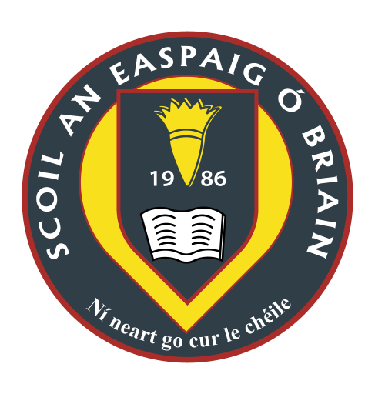
ANNUAL ADMISSION NOTICE
in respect of admissions to the 2023/2024 school year

Admission Policy and Application Form
A copy of the school’s Admission Policy for the 2023/2024 school year is available to download at www.bartlemyns.net and the Application Form for Admission for the 2023/2024 school year should be completed and submitted using the “Enrol here” link.

PART 1 - Admissions to the 2023/2024 school year

Application and Decision Dates for admission to Junior Infants 2023/2024
The following are the dates applicable for admission to Junior Infants

The school will commence accepting applications for admission on | 14/11/2022
The school shall cease accepting applications for admission on | 09/12/2022
The date by which applicants will be notified of the decision on their application is | 16/12/2022
The period within which applicants must confirm acceptance of an offer of admission is | 13/01/2023

Note: the school will consider and issue decisions on late applications in accordance with the school’s admission policy.

*Failure to accept an offer within the prescribed period above may result in the offer being withdrawn.

Number of places being made available in 2023/2024

The number of places being made available in Junior Infants is | 21

